LOGOS TO BE ADDED
All these logos are proposed to be added as a scroll in the home page with the heading of “Institutional Collaborators”. Just the logos of each institution need to be scrolled. No need to mention their name. Also, it would be best if we could arrange a hyper link for the respective logos. Once someone clicks a particular logo, it should direct to that particular institution’s website.



https://www.sathyabama.ac.in/academics/schools/school-law


https://care.edu.in/school/school-of-law/about/



https://www.tndalu.ac.in/


https://ifheindia.org/lp/icfailaw2026/?utm_source=VidyaVision&utm_medium=Email_Camp&utm_campaign=ICFAI_LAW_2026&gad_source=1&gad_campaignid=23290681646&gbraid=0AAAAAolEZpwmQEujnLa0vAkpWjtuuyHNM&gclid=CjwKCAjwyYPOBhBxEiwAgpT8P2IQvvpvydzGWpiB6gKO-Z5Oe_8mwSwwoLnUzoEyyF1gSv4ilFjk4xoCZTUQAvD_BwE

https://applications.srmist.edu.in/law?utm_source=Esquared&utm_medium=Google_Search&utm_campaign=SRM_5_Year_UG_Law_Brand_Search_2026&utm_adgroupid=199686364308&utm_campaignid=23430770561&utm_keyword=srm%20law&utm_device=c&utm_network=g&utm_matchtype=p&gad_source=1&gad_campaignid=23430770561&gbraid=0AAAAApToRECKGcedWdp4UMXAHVDmCADZh&gclid=CjwKCAjwyYPOBhBxEiwAgpT8P4h_5WyjS4vgduP7cF8CYu2hGre2Cv1RWcQRahib9v7jYXdePMQCHBoCEjUQAvD_BwE


https://law.drmgrdu.ac.in/


https://www.dsuniversity.ac.in/index.php


https://vmls.edu.in/


https://www.gregorioulaw.com/


https://nitipartners.com/


https://orta-gs.com.mx/nuestra-firma

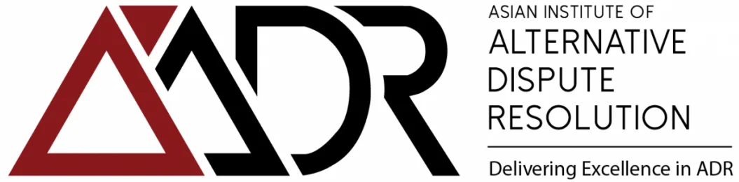
https://aiadr.world/

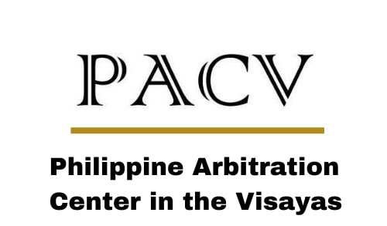
https://pacv.usa.edu.ph


https://jusconnect.com/en/d/profile/institution/en-latin-american-center-for-arbitration-and-mediation-centro-latinoamericano-de-arbitraje-y-mediacin-1


https://iamch.org.in/


https://nccdrc.org


https://en.scia.com.cn/


https://niac.asia/


https://www.aiac.world/


https://www.linkedin.com/company/indonesia-international-arbitration-center-iniac/?originalSubdomain=id

